Six Week Christmas Countdown 2022
Monday | Tuesday | Wednesday | Thursday | Friday | Saturday | Sunday
Nov 14 | 15 | 16 | 17 | 18 | 19   | 20
21    Continue  Buying  Presents | 22 | 23 | 24 | 25  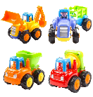  Late Late Toy Show  This Photo by Unknown Author is licensed under CC BY-NC | 26 | 27
28 | 29  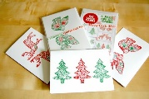 | 30 | Dec 1 | 2 | 3 |   4
5 | 6 | 7 | 8 | 9 | 10 |   11  This Photo by Unknown Author is licensed under CC BY-NC
12 | 13 | 14 | 15 | 16 |   17  This Photo by Unknown Author is licensed under CC BY | 18
19 | 20 | 21 | 22 | 23 |   24 |   25

